Restaurant Bill Generation

A MINI PROJECT REPORT

Submitted by:

# Vijay S (210419205059)



ANNA UNIVERSITY : CHENNAI 600 025

# JULY 2022



**DEPARTMENT OF INFORMATION TECHNOLOGY**

CHENNAI INSTITUTE OF TECHNOLOGY

# JULY 2022

**CANDIDATE’S DECLARATION**

I’m, Vijay S student of B.Tech (Information Technology), hereby declare that the Project Dissertation titled — “Restaurant Bill Generation” which is submitted by me to the Department of Information Technology, Chennai Institute of Technology, Chennai. This work has not previously formed the basis for the award of any Degree, Diploma, Fellowship or other similar title or recognition.

Place: Chennai

Date: 26/07/2022

# Vijay S

# (210419205059)

**Abstract**

This project “Restaurant Bill Generation” is Developed to generate a computerized Bill to the customer. This generated bill contains the Restaurant name ,food items, Quantity and Price. The Computerized bill generate the Accurate total to the customer. It can calculate faster then the human. The Project is developed using the Object Oriented Programming Language called Java. It includes java Concepts like Strings, For loop, Arrays, Attributes, Constructors, Method overloading ,Encapsulation , Abstraction ,Inheritance. The most important benefit of the bill is to record the sale of the day. This make it possible to find out which food sale faster. By providing the printed bill to the customer . The customer can stop the problem of repeating the same food again.

**Introduction**

Businesses need to create invoices to ensure they get paid by their clients. Invoices serve as legally enforceable agreements between a business and its clients, as they provide documentation of services rendered and payment owed.

Invoices also help businesses track their sales and manage their finances. Invoices provide valuable data regarding how your sales change over time and can help you create accurate business forecasts. Invoices can also help you determine the average amount of time it takes you to receive payment from your clients, which can help you manage your cash flow.

In the US, it’s only mandatory to issue invoices for business-to-business (B2B) sales. Most freelancers and small businesses also opt to issue invoices to consumers in order to keep a thorough record of all their income and sales.

Therefore, both self-employed workers and companies can use their invoices for record-keeping purposes and to declare their income to the tax authorities.

Another benefit to invoicing is to control your incoming and outgoing payments. Regardless of whether you’re a freelancer or a corporation, keeping track of your cash flow can help keep your business in a healthy financial state.

It’s important to regularly check which invoices have been paid, and which invoices are overdue and require follow-up. Invoicing software can assist you in making sure that no invoices are overlooked.

**System Requirement:**

Operating System : Linux , Windows , Mac.

Integrated Development Environment : VScode , Eclipse , IntelliJ IDEA .

RAM : 1GB.

Disk Space : 250 GB.

Processor : Minimum Pentium 2.

Browser : Internet Explorer , Firefox , Google , Microsoft Edge.

**Flow Chart**

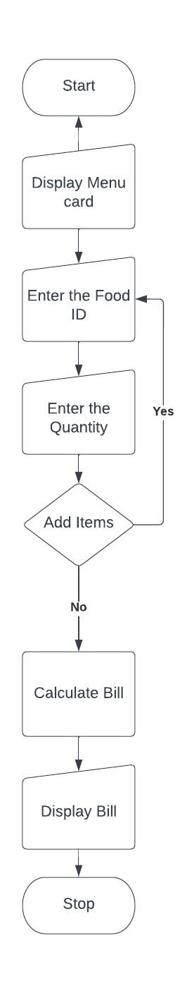

**Why JAVA?**

* Java works on different platforms (Windows, Mac, Linux, Raspberry Pi, etc.).
* It is one of the most popular programming language in the world.
* It is easy to learn and simple to use.
* It is open-source and free.
* It is secure, fast and powerful.
* It has a huge community support (tens of millions of developers).
* Java is an object oriented language which gives a clear structure to programs and allows code to be reused, lowering development costs.
* As Java is close to C++ and C#, it makes it easy for programmers to switch to Java or vice versa.

**Project Details:**

Functional Requirement

* Classes are used to get Input from the user
* Arrays are used to Store the Food items , Price
* Simple Calculations are used to Calculate the bill.
* OOPS concepts are used to Hide the information, Reuse the code, flexibility.

Non-Functional Requirement

I. Robustness: Robustness is nothing but its ability to tolerate the effects of the system's fictional body. And it can also be defined by its system’s ability that it can withstand change without transforming its initial stable configuration.

II. Reliability: The system is trustworthy and it is consistently good in performance. It can also be stated as the system performs the function without any failure under certain conditions and specified period of time.

III. Availability: The system is available 247, Availability and Reliability are directly proportional as reliability increases availability also increases. The ser can have access to the system all the time.

IV. Reusability: The system can be used any number of times by the specific user. And the reusability is consistent, adaptable and stable

V. Effectiveness: The algorithm is capable of producing desired results or it has the ability to provide better results.

**OUTPUT:**

